Fun 06 : Three.js

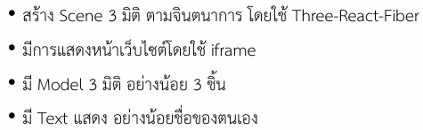

App.jsx

* sets up a 3D scene using Three.js and react-three-fiber.

Style.css

* setup creates a fullscreen 3D experience

Experience.jsx

* Import libraries and add the objects from web : <https://market.pmnd.rs/>
* Show and adjust the object to the position we want to.
* Add the message box from Dr. Suriya.
* Add two websites for my computer and my phone.
* Add my name as a text.
* Add some shadow.

Add the object link to the const name.

Show the object and adjust their position.

Message box from Dr.Suriya told me to study eiei.

Two websites

* First is for my computer showing the LEB2 of Dr.Suriya video.
* Second is for my phone showing the google translate (actually I want to link YouTube but they are not allow).

I added my full name as a text because Dr.Suriya want to and add some shadow to make an object reality.

RESULT

